Real Time & Embedded Systems

Project 4

October 14, 2015

Harshdeep Singh Chawla

[hxc3427@g.rit.edu](mailto:hxc3427@g.rit.edu)

Christopher Rouleau

[crr9988@rit.edu](mailto:crr9988@rit.edu)

**Areas of Focus:**

Harshdeep:

* Design and implementation of code on QNX Neutrino.
* Report work.

Christopher:

* Design and implementation of code on QNX Neutrino.

**Analysis / Design:**

Customers: Customers enter the bank. Each new customer arrives in every one to four minutes (depending upon a uniform random distribution). There is a single queue for all customers.

Tellers: There are three tellers available to provide service to the customers waiting in the queue. If any of the three tellers is idle, customer leave the queue, approach the teller for their work. Each customer can stay with teller for 30 seconds to 6 minutes to discuss their problem. The time frame for a customer to talk to teller is based on a uniform random distribution.

Bank: The bank is open form 9:00am and 4:00pm (seven hours). Customers start entering as the bank opens in the morning, and stops when the bank closes in the afternoon. Customers in the queue at the time of closing remain in the queue until they visit one of the tellers.

Graduate Problem: Each teller will take a random break every 30 to 60 minutes for a duration of 1 to 4 minutes each. A break can only occur after the completion of customer transactions. The break timing and duration is based on a random uniform distribution.

Metrics: To monitor the performance of the business, metrics are gathered and reported at the end of the day. The metrics are:

* the total number of customers serviced during the day,
* the average time each customer spends waiting in the queue,
* the average time each customer spends with the teller,
* the average time tellers wait for customers,
* the maximum customer wait time in the queue,
* the maximum wait time for tellers waiting for customers,
* the maximum transaction time for the tellers, and
* the maximum depth of the queue.

Design Constraints: Each customer is represented as an application task (i.e. TCB). Each teller is modeled as an independent thread. The simulation parameters are variable and assigned at program startup. The simulation time is scaled such that 100 milliseconds of absolute clock time represents 1 minute of simulation clock time. The output should be presented in simulation clock time.

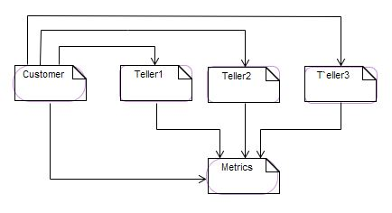

FIG-FLOW WORK OF SYSTEM

The following is a list of design features:

* Code initiates 4 threads, one to handle the timer and three for the tellers
* Timer runs for the 420 minutes of the work day and generates a new customer randomly and adds them to the queue
* If teller is open they take a customer from the queue and service them over a random period of time
* Tellers continue to service until queue is empty

**Lessons Learned:**

In this project we learned about the basic features of the QNX and how to use them. As it was the first time we have used QNX, there was a pretty steep learning curve. A major challenge was determining the information we needed to know and then finding it within the manuals. However, once an initial general understanding of the hardware was achieved, this process became fairly straightforward. Another challenge encountered was adequately dividing the work and responsibilities. Developing cross discipline skills is important as a student and it later becomes essential when entering industry.

**References: -**

1. Matter posted on RIT-mycourses.
2. https://github.com.